Modal Analysis of a Cantilever Beam

Introduction
This tutorial was created using ANSYS 7.0 The purpose of this tutorial is to outline the steps required to do a simple modal analysis of the cantilever beam shown below.
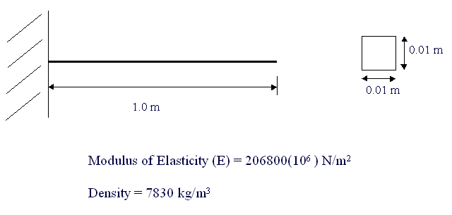

Preprocessing: Defining the Problem
The simple cantilever beam is used in all of the Dynamic Analysis Tutorials. If you haven't created the model in ANSYS, please use the links below. Both the command line codes and the GUI commands are shown in the respective links.

Solution: Assigning Loads and Solving
- Define Analysis Type
Solution > Analysis Type > New Analysis > Modal
ANTYPE,2
- Set options for analysis type:
  - Select: Solution > Analysis Type > Analysis Options..
The following window will appear
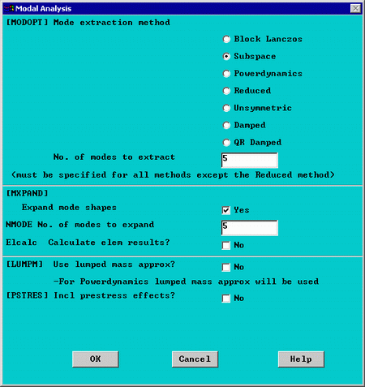
  - As shown, select the Subspace method and enter 5 in the 'No. of modes to extract'
  - Check the box beside 'Expand mode shapes' and enter 5 in the 'No. of modes to expand'
  - Click 'OK'
Note that the default mode extraction method chosen is the Reduced Method. This is the fastest method as it reduces the system matrices to only consider the Master Degrees of Freedom (see below). The Subspace Method extracts modes for all DOF's. It is therefore more exact but, it also takes longer to compute (especially when the complex geometries).
  - The following window will then appear
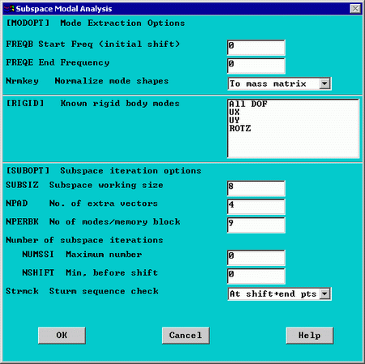
For a better understanding of these options see the Commands manual.
  - For this problem, we will use the default options so click on OK.
- Apply Constraints
Solution > Define Loads > Apply > Structural > Displacement > On Keypoints
Fix Keypoint 1 (ie all DOFs constrained).
- Solve the System
Solution > Solve > Current LS
SOLVE

Postprocessing: Viewing the Results
- Verify extracted modes against theoretical predictions
  - Select: General Postproc > Results Summary...
The following window will appear
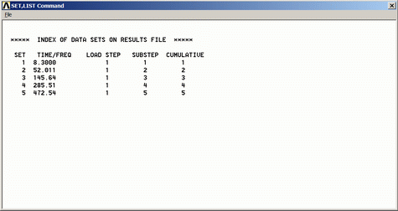
The following table compares the mode frequencies in Hz predicted by theory and ANSYS.
Mode | Theory | ANSYS | Percent Error
1 | 8.311 | 8.300 | 0.1
2 | 51.94 | 52.01 | 0.2
3 | 145.68 | 145.64 | 0.0
4 | 285.69 | 285.51 | 0.0
5 | 472.22 | 472.54 | 0.1
Note: To obtain accurate higher mode frequencies, this mesh would have to be refined even more (i.e. instead of 10 elements, we would have to model the cantilever using 15 or more elements depending upon the highest mode frequency of interest).
- View Mode Shapes
  - Select: General Postproc > Read Results > First Set
This selects the results for the first mode shape
  - Select General Postproc > Plot Results > Deformed shape . Select 'Def + undef edge'
The first mode shape will now appear in the graphics window.
  - To view the next mode shape, select General Postproc > Read Results > Next Set . As above choose General Postproc > Plot Results > Deformed shape . Select 'Def + undef edge'.
  - The first four mode shapes should look like the following:
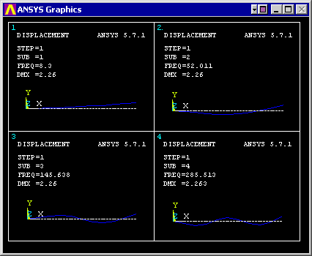
- Animate Mode Shapes
  - Select Utility Menu (Menu at the top) > Plot Ctrls > Animate > Mode Shape
The following window will appear
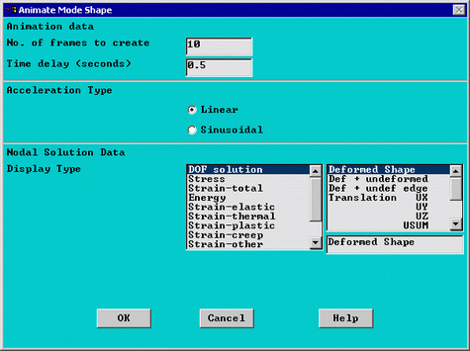
  - Keep the default setting and click 'OK'
  - The animated mode shapes are shown below.
    - Mode 1
    - Mode 2
    - Mode 3
    - Mode 4

